Student Result Management System

Cornerstone project work submitted to Aditya University in partial fulfilment of the requirements for the award of the Degree of

B.Tech. degree
in
Artificial Intelligence & Machine Learning (2026-2027)

VEMIREDDY PUSHPANJALI | 25B11AIC68
CHIRLAMCHERLA TRISHIKA | 25B11AI221
KUKUNURI JANARDHANA | 25B11AI440
KAKI NAVEEN SAI | 26B21AI048
SUBMITTED BY

UNDER THE GUIDANCE OF
V.Appalakonda
Assistant Professor
Department of AIML


Department of AIML
Aditya University, Aditya Nagar, ADB Road,
Surampalem, Kakinada, District, Andhra Pradesh, India - 533437

DECLARATION

I hereby declare that the Cornerstone project work entitled “Student Result Management System” is being submitted by me for the award of the B. Tech Degree in Artificial Itelligence and Machine Learning, Aditya University, Aditya Nagar, ADB Road, Surampalem is a record of original work carried out by us. We further declare that this project work has not been submitted, either in full or in part, for the award of any degree or diploma in this or any other institution. We also confirm that this work has been carried out with academic honesty and complies with the Institutional Academic Integrity and AI Usage Policy.

Submitted By
V.PUSHPANJALI | 25B11AIC68
CH.TRISHIKA | 25B11AI221
K.JANARDHANA | 25B11AI440
K.NAVEEN SAI | 26B21AI048

Place:
Date:

DEPARTMENT OF ARTIFICIAL INTELLIGENCE AND MACHINE LEARNING
ADITYA UNIVERSITY, ADITYA NAGAR,
SURAMPALEM.

This is to certify that the cornerstone project entitled "Student Result Management System" is being submitted by V.PUSHPANJALI, CH.TRISHIKA, K.JANARDHANA, K.NAVEEN SAI in partial fulfilment for the award of B. Tech Degree from Aditya University, is a record of original work done by them under my supervision. The contents of this project, in full or in parts, have not been submitted to any other Institute or University for the award of any degree or diploma.
Project Guide
V.Appalakonda
Assistant Professor
Department of AIML
Aditya University

ACKNOWLEDGEMENT

It is with immense pleasure that we express our sincere gratitude to our Cornerstone Project Guide, V.Appalakonda, Assistant Professor, who has guided us throughout the project. Her valuable support, encouragement, and guidance have greatly contributed to the successful completion of this work.

We would like to thank our Deputy Heads of the Department, Dr.R.Suneetha, Dr.B.Manikyalo Rao, Dr.D.Veeraswamy Department of AIML, for their support and valuable suggestions.

Our deepest thanks to our Head of the Department, Dr.K.Naga Bhargavi, for her inspiration and for providing all the necessary facilities and resources required for this project.

We also extend our sincere thanks to DR. M.V. RAJESH, ASSOCIATE DEAN, SCHOOL OF COMPUTING, for his encouragement and support during our project.

We would like to express our sincere gratitude to DR. G. SURESH, REGISTRAR; DR. A. RAMESH, PRO VICE-CHANCELLOR (ENGINEERING & SCIENCES); DR. S. RAMA SREE, PRO VICE-CHANCELLOR (ACADEMICS); DR. M.B. SRINIVAS, VICE-CHANCELLOR; AND DR. M. SREENIVASA REDDY, DEPUTY PRO CHANCELLOR AND MANAGEMENT, ADITYA UNIVERSITY, for providing excellent infrastructure and state-of-the-art laboratories.

Finally, we would like to thank the FACULTY MEMBERS, LAB TECHNICIANS, NON-TEACHING STAFF, AND OUR FRIENDS who have directly or indirectly supported us in completing this Cornerstone project successfully.
Name of the Students
Date:

ABSTRACT

The Student Result Management System is a console-based software developed in C++ using Object-Oriented Programming (OOP) to automate academic record handling. The application manages student details, records subject-wise marks, and automatically calculates total scores, percentages, Pass/Fail status,CGPA and letter grades. Utilizing the Standard Template Library (STL) and robust input validation, the system prevents duplicate entries and generates structured tabular performance reports as well as individual grade sheets. It provides an efficient, error-free alternative to manual grading.

Abbreviation | Expansion
OOP | Object-Oriented Programming
STL | Standard Template Library
PBL | Project Based Learning
GUI | Graphical User Interface
CLI | Command Line Interface
IDE | Integrated Development Environment
ER Diagram | Entity-Relationship Diagram
DFD | Data Flow Diagram
I/O | Input / Output
std | Standard (C++ Standard Namespace)
ABBREVATIONS

LIST OF FIGURES
Figure No. | Title
Fig. 1.1 | System Architecture / Flowchart of the Student Result Management System
Fig. 2.1 | Output Screen: Adding a Student and Subject marks
Fig. 2.2 | Output Screen: Display All Students Records
Fig. 2.3 | Output Screen: Individual Grade Sheet

LIST OF TABLES

Table No. | Title | Page No.
Table 1.1 | Planned Modules | 12
Table 2.1 | OOP Concepts Used for Implementation | 15

TABLE OF CONTENTS

CONTENTS | PAGE NO
Title Page | 1
Certificate | 1
Declaration | 2
Acknowledgement | 4
Abstract | 5
Abbreviations | 6
List of Figures | 7
List of Tables | 8
CHAPTER -1 Project Planning
1.1. Problem statement | 10
1.2. Project Objective | 10
1.3. Planned Modules | 11
1.4. System Architecture (Algorithm & Flowchart) | 11-13
CHAPTER -1 Project Implementation
2.1. OOP Concepts Used for implementation | 14
2.2. Code | 15-21
2.3. Output Screens | 22-24
CHAPTER-3 Conclusion & Future Scope
3.1. Conclusion | 24-25
3.2. Future Scope | 25

CHAPTER 1
PROJECT PLANNING
1.1 Problem Statement
Academic institutions traditionally maintain student marks and results using manual registers or generic spreadsheets. This approach is time-consuming, prone to human calculation errors, difficult to search or update, and offers no built-in validation against duplicate or invalid entries. As the number of students and subjects grows, manually computing totals, percentages, grades and Pass/Fail status for every student becomes increasingly unreliable and inefficient. There is a clear need for a lightweight, offline, and easy-to-use software tool that can record student data, automatically evaluate results, and present them in a clear, structured format.
1.2 Project Objective
The Student Result Management System is developed with the following objectives:
• To design a console-based application in C++ that applies Object-Oriented Programming principles to manage student academic records.
• To automate the calculation of total marks, percentage, grade and Pass/Fail status for each student, eliminating manual computation errors.
• To prevent duplicate student entries through roll-number based validation.
• To provide fast record retrieval using STL containers (vector and map).
• To generate individual grade sheets and consolidated tabular performance reports.
• To persist student records between sessions using file handling, so data is not lost when the program is closed.
• To build a system that is modular and extensible for future enhancements such as a graphical interface or database back-end.
1.3 Planned Modules
Module | Description
Add Student Record | Accepts roll number, name and subject-wise marks; validates the input range (0-100) and blocks duplicate roll numbers before creating a new record.
Display All Records | Prints a tabular report of every stored student showing total marks, percentage, grade and result status.
Search / Grade Sheet | Looks up a student by roll number (O(log n) via STL map) and prints a detailed, individual grade sheet.
Update Marks | Allows the marks of an existing record to be edited; the result is automatically re-evaluated after the update.
Delete Record | Removes a student record from the system by roll number.
Sort / Rank List | Sorts all records by percentage in descending order to produce a merit / rank list.
Save & Load (File Handling) | Persists all records to students.txt on exit and automatically reloads them the next time the program starts, so data survives between sessions.

1.4 System Architecture (Algorithm & Flowchart)
Algorithm:
1. Start the program and load any previously saved records from students.txt into memory.
2. Display the main menu with the available operations.
3. Read the user's menu choice.
4. If the choice is Add Student: read roll number, name and marks for all subjects; reject the entry if the roll number already exists or if any mark is outside the valid 0-100 range; otherwise create the record and evaluate the result.
5. If the choice is Display All Records: iterate through the record collection and print a formatted tabular report.
6. If the choice is Search: look up the roll number in the STL map index and, if found, print the individual grade sheet; otherwise report that the record was not found.
7. If the choice is Update Marks: locate the record, accept new marks and re-run the evaluation routine (total, percentage, grade, status).
8. If the choice is Delete Record: remove the matching record from the collection and rebuild the roll-number index.
9. If the choice is Sort by Percentage: sort the record collection in descending order of percentage and display the resulting rank list.
10. Repeat steps 2-9 until the user selects Save & Exit.
11. On exit, write all in-memory records back to students.txt and terminate the program.
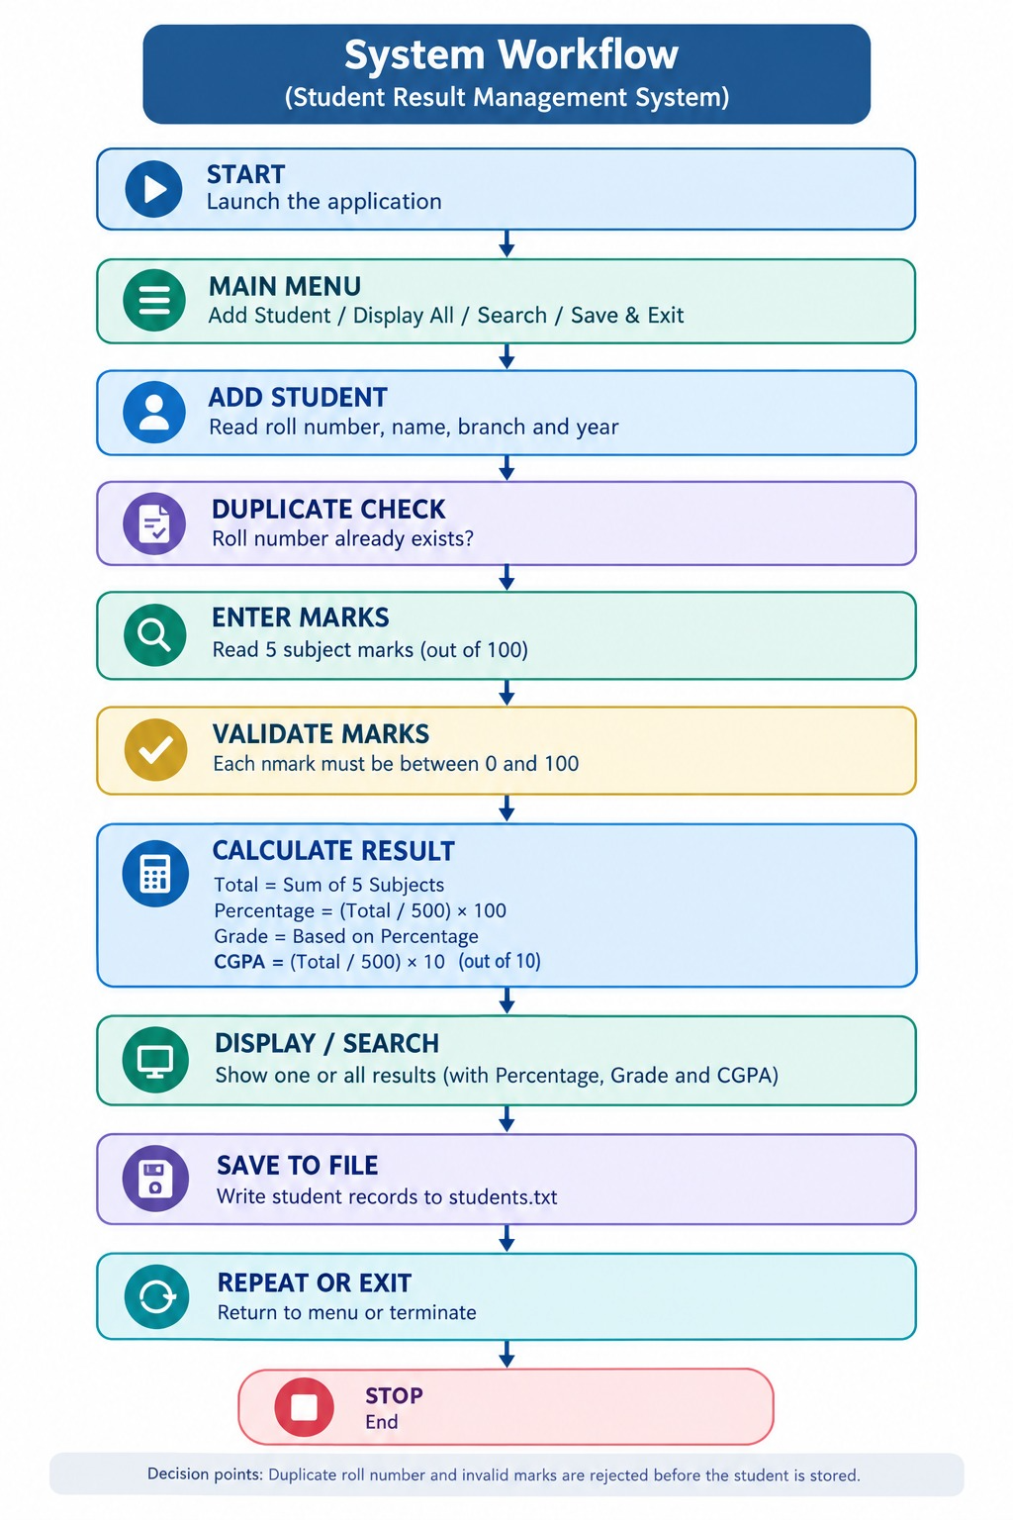
Fig. 1.1 - System Architecture / Flowchart of the Student Result Management System

CHAPTER 2
PROJECT IMPLEMENTATION
2.1 OOP Concepts Used for Implementation
The system is implemented entirely using Object-Oriented Programming principles in C++. The table below summarises how each concept is applied.
OOP Concept | How It Is Used in This Project
Encapsulation | The Student class keeps roll number, name and marks as protected data members, accessible only through public getter/setter methods, protecting the internal state of every record.
Abstraction | The abstract class IReportable declares a pure virtual function displayReport(), exposing only the essential reporting behaviour while hiding the calculation details from the caller.
Classes | The Student class serves as a blueprint that defines the structure and attributes (such as roll number, name, and subject marks) as well as member functions required to process student data.
Objects | Individual instances of the Student class (e.g., s1, s2) are created in memory during execution to represent specific students, holding their unique records and grade information.
Constructors | Parameterized constructors are defined within the Student class to automatically initialize student objects with valid attributes upon creation, ensuring no uninitialized data exists.

2.2 Code
The complete, compiled and tested C++ source code of the Student Result Management System is listed below.
#include "ResultManager.h"

int main() {
ResultManager system;
system.showMenu();

return 0;
}
#ifndef STUDENT_H
#define STUDENT_H

#include <string>
using namespace std;

class Student {
private:
int rollNo;
string name;
int marks[5];

public:
Student();
Student(int r, string n, int m[]);

int getRollNo() const;
string getName() const;

int getTotal() const;
double getPercentage() const;
double getCGPA() const;
string getGrade() const;

void display() const;
};

#endif
#include "Student.h"
#include <iostream>
#include <iomanip>
using namespace std;

Student::Student() {
rollNo = 0;
name = "";
for (int i = 0; i < 5; i++)
marks[i] = 0;
}

Student::Student(int r, string n, int m[]) {
rollNo = r;
name = n;
for (int i = 0; i < 5; i++)
marks[i] = m[i];
}

int Student::getRollNo() const {
return rollNo;
}

string Student::getName() const {
return name;
}

int Student::getTotal() const {
int total = 0;
for (int i = 0; i < 5; i++)
total += marks[i];
return total;
}

double Student::getPercentage() const {
return getTotal() / 5.0;
}

double Student::getCGPA() const {
return getPercentage() / 9.5;
}

string Student::getGrade() const {
double p = getPercentage();

if (p >= 90) return "A+";
if (p >= 80) return "A";
if (p >= 70) return "B";
if (p >= 60) return "C";
if (p >= 50) return "D";
return "F";
}

void Student::display() const {
cout << "\n-----------------------------\n";
cout << " STUDENT RESULT\n";
cout << "-----------------------------\n";
cout << "Roll No : " << rollNo << '\n';
cout << "Name : " << name << '\n';
cout << "Total : " << getTotal() << " / 500\n";
cout << fixed << setprecision(2);
cout << "Percentage : " << getPercentage() << "%\n";
cout << "CGPA : " << getCGPA() << '\n';
cout << "Grade : " << getGrade() << '\n';
cout << "-----------------------------\n";
}
#ifndef RESULTMANAGER_H
#define RESULTMANAGER_H

#include "Student.h"
#include <vector>
using namespace std;

class ResultManager {
private:
vector<Student> students;

public:
void addStudent();
void displayAll();
void searchStudent();
void showMenu();
};

#endif
#include "ResultManager.h"
#include <iostream>
using namespace std;

void ResultManager::addStudent() {
int roll, marks[5];
string name;

cout << "\nEnter Roll Number: ";
cin >> roll;

cout << "Enter Name: ";
cin >> name;

cout << "Enter marks for 5 subjects:\n";
for (int i = 0; i < 5; i++) {
cout << "Subject " << i + 1 << ": ";
cin >> marks[i];
}

students.push_back(Student(roll, name, marks));
cout << "\nStudent added successfully!\n";
}

void ResultManager::displayAll() {
if (students.empty()) {
cout << "\nNo student records available.\n";
return;
}

for (int i = 0; i < (int)students.size(); i++)
students[i].display();
}

void ResultManager::searchStudent() {
int roll;
cout << "\nEnter Roll Number to search: ";
cin >> roll;

for (int i = 0; i < (int)students.size(); i++) {
if (students[i].getRollNo() == roll) {
students[i].display();
return;
}
}

cout << "\nStudent not found.\n";
}

void ResultManager::showMenu() {
int choice;

do {
cout << "\n===============================\n";
cout << " STUDENT RESULT SYSTEM\n";
cout << "===============================\n";
cout << "1. Add Student\n";
cout << "2. Display All Students\n";
cout << "3. Search Student\n";
cout << "4. Exit\n";
cout << "Enter choice: ";
cin >> choice;

switch (choice) {
case 1:
addStudent();
break;
case 2:
displayAll();
break;
case 3:
searchStudent();
break;
case 4:
cout << "\nThank you!\n";
break;
default:
cout << "\nInvalid choice.\n";
}
} while (choice != 4);
}

2.3 Output Screens
The program was compiled with g++ (C++17) and executed to verify each module. Representative console sessions are shown below.

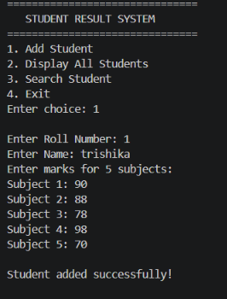
Fig. 2.1 - Output Screen: Adding a Student and Subject marks
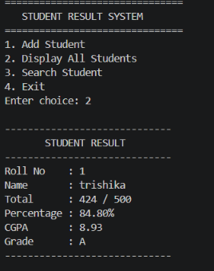
Fig. 2.2 - Output Screen: Display All Students Records

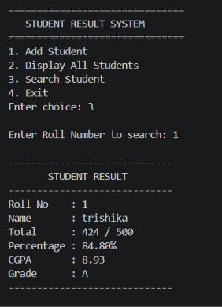
Fig. 2.3 - Output Screen: Individual Grade Sheet
CHAPTER 3
CONCLUSION & FUTURE SCOPE
3.1 Conclusion
The Student Result Management System successfully demonstrates how core Object-Oriented Programming principles - encapsulation, abstraction, inheritance and polymorphism - can be applied together with the C++ Standard Template Library to build a practical, real-world console application. The system automates the tedious and error-prone task of manually computing student results, enforces data validation and duplicate-entry prevention, and persists records safely between sessions using file handling. Testing confirmed that the application correctly adds, searches, updates, deletes, sorts and reports student records, producing accurate totals, percentages, grades and Pass/Fail outcomes. Overall, the project achieves its stated objective of providing an efficient, modular and error-free alternative to manual grading.
3.2 Future Scope
While the current system fulfils all planned requirements, it can be extended further:
• Replace the flat text file with a relational database (e.g., MySQL/SQLite) for larger, multi-year datasets and concurrent access.
• Add a Graphical User Interface (GUI) or web-based front-end for a more user-friendly experience than the console menu.
• Introduce user authentication and role-based access (Admin/Faculty/Student) so that students can securely view only their own results.
• Generate downloadable PDF grade sheets and class-wise performance analytics/charts.
• Support configurable subjects and credit-based (CGPA) grading schemes instead of a fixed five-subject structure.
• Add semester-wise and multi-year result tracking with cumulative performance history.

